Azure Data Bricks Connecting Delta lake
(Umesh Chithaluri, Member Technical Staff)
Keywords: Azure Data Bricks, Delta lake
Introduction:
Delta Lake is an open source storage layer that sits on top of cloud storage technology such as Azure Data Lake Storage or Amazon S3. The technology was introduced by Data bricks in 2019, and all of the code is available here. Delta Lake is an extension of Spark and markets the fact that it brings ACID transactions to data lakes. This is a huge step forward for data engineers.
Data integrity on data lakes is a challenge today due to the fact that failed ETL jobs can cause partial data to be written or corrupted. With Delta Lake, you are able to guarantee a write operation either completes fully or not at all, and thus prevent corrupt data.
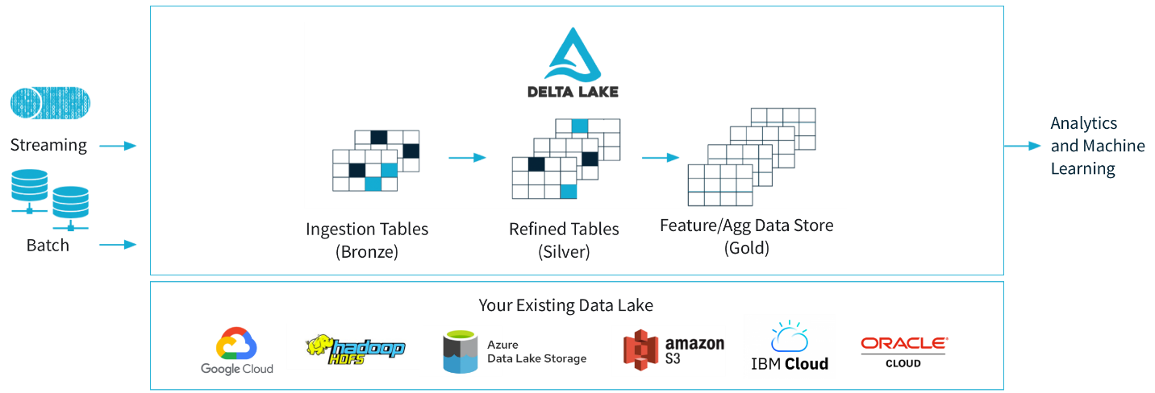
Top Four Reasons to Build a Data Lake
1) It’s unifying:
As your data needs expand it becomes harder and harder to work with data kept in multiple different silos. It may make sense from a product perspective for your traffic data to be in Google Analytics, your sales records to be in Salesforce and your trial engagement data to be in some database. However, when you need to analyze your funnel and attribution models you need them all together. In a Data Lake, all data can be combined so it can be analyzed together.

2) Full query access:
The applications your business uses likely only offer transactional API access to the data. They’re not designed for reporting, so unless the data is exported and put into a format you can easily query, you will end up being very limited in what you can pull. These APIs, if used directly for reporting, can also become prohibitively expensive.

3) Performance:
Source data might be from the actual production database which could affect the performance of the application that it is powering. Queries that demand a lot of data such as aggregations are not optimally run on transactional databases.
4) Progress:
Getting the data in one spot is a necessary step for progressing to the other stages. It makes working with data so much easier that many BI products require this stage - as they will only connect to a single warehouse source.

What is Data bricks: Data bricks Integrations?

Data bricks is basically a Cloud-based Data Engineering tool that is widely used by companies to process and transform large quantities of data and explore the data. This is used to process and transform extensive amounts of data and explore it through Machine Learning models. Data bricks integrates with a wide range of developer tools, data sources, and partner solutions.
- Data Sources: Data bricks can read and write data from/to various data formats such as Delta Lake, CSV, JSON, XML, Parquet, and others, along with data storage providers such as Google Big Query, Amazon S3, Snowflake, and others.
- Developer Tools: Data bricks supports various tools such as IntelliJ, Data Grip, PyCharm, Visual Studio Code, and others.
- Partner Solutions: Data bricks has validated integrations with third-party solutions such as Power BI, Tableau, and others to enable scenarios such as Data
7) Key Functionalities of Delta Lake:
- ACID Transactions
As mentioned earlier, ACID transactions capability is a huge advancement for data lakes. Typically, a data lake has numerous data streams with users reading data from and writing data to the lake. Delta Lake stores a transaction log (Delta Log) which tracks all commits made to a directory since the beginning of time. This prevents “dirty reads” by the users.

- Schema Enforcement
Delta Lake allows you to specify your schema and enforce it. This prevents the insertion of bad records during data integration

- Schema Evolution
Data changes over time and thus data engineers need to be able to adjust a table schema. Delta Lake provides the ability to easily make those change

4.Time Travel

The Delta Log allows users to return to an older version of the data. This rollback functionality means bad updates can be reverted, data can be audited, and older copies of the data can be accessed for experimentation. Users have the ability to query the data using an “as of” timestamp. See below for an example SQL query:

5.Parquet

Data in the Delta Lake is stored in Apache Parquet format. This provides for valuable compression and encoding schemes that are native to Parquet.

6.Data Manipulation (DML)
Delta Lake provides the ability to merge, update, and delete data sets. This allows data engineers to comply with the most stringent of data regulations, such as GDPR and CCPA.This can be done using various APIs like Scala, Java, and Python.

7.Metadata Management
Delta Lake treats metadata no different than data. The power of Spark’s distributed engine makes metadata management efficient. This means petabyte size tables with millions of partitions and files can be handled with ease.

Prerequisites:
To use this Azure Data bricks Delta Lake connector, you need to set up a cluster in Azure Data bricks.
- To copy data to delta lake, copy activity invokes Azure Data bricks cluster to read data from an Azure Storage which is either your original source or staging area to where the service firstly writes the source data via built-in staged copy
- write data to an Azure Storage

steps to create a linked service to Azure Data bricks Delta Lake in the Azure portal UI.
1) Sign in to the Azure portal.
2)Browse to the Manage tab in your Azure Data Factory or Synapse workspace and select Linked Services, then click New:
3) Search for delta and select the Azure Data bricks Delta Lake connector.
4)Configure the service details, test the connection, and create the new linked service.

Benefits:

1)Caching
2)Time Travel
3)Merging Datasets
4)Optimization
5)Schema Evolution

References:
- https://docs.databricks.com/?_ga=2.51707438.643994833.1656064855-630075061.1644902886
- https://docs.databricks.com/getting-started/introduction/index.html

About Author:

Umesh Chithaluri holds Bachelor’s Degree in Electronics & Communication Engineering from TKR College Hyderabad. He is currently working as Member Technical Staff with ERS Research team and involved in Data Engineering products development

